|  |  |  |  |  |  |  |  |  |
| --- | --- | --- | --- | --- | --- | --- | --- | --- |
| |  | | --- | | Benro tripod - T980 | | Product image thumb |  |  |  |  |  | | --- | --- | --- | --- | | Product image thumb | Product image thumb | Product image thumb |  | |  | **Featured information**  The Benro - T980 tripod features a sturdy aluminum alloy design with a load capacity of up to 5kg. Users can flexibly control the tripod, rotate the camera in many directions easily, create impressive photos from many different angles or unique vertical photo frames.  **Price: 110$**  **Specifications:**   * **Weight:** 1.2kg * **Max height:** 169 cm * **Minimum height:** 67.5 cm * **Load bearing:** 5 Kg |

**Description:**

#### **Benro - T980 tripod**

Benro - T980 tripod has a design from sturdy aluminum alloy with a load capacity of up to 5kg. Users can control the tripod flexibly, rotate the camera in many directions easily, create impressive photos from many different angles or unique vertical photo frames.

#### **Benro Tripod - T980**

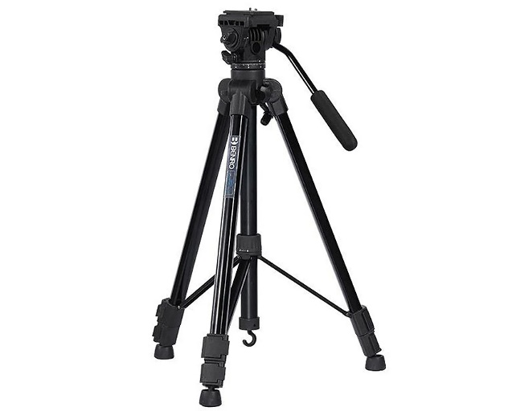

The tripod design is not only compatible with mirrorless cameras and DSLR cameras, but you can also combine it with accessories to use with your smartphone. The base of the tripod is rubber coated, helping the Benro - T980 stand firmly on different surfaces.